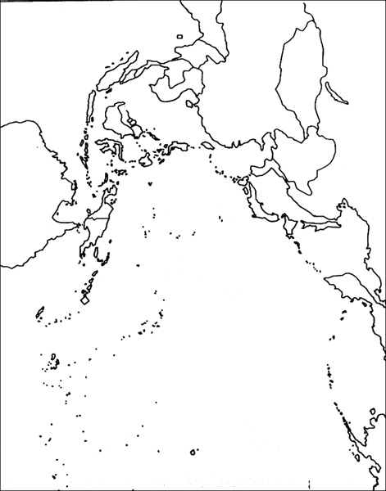

“War in the Pacific”
Map Activity

Like the map activity you completed for the European Theater, this map activity will help you develop the geographic knowledge needed to visualize what was happening in this part of the conflict. Often, the military engagements that took place happened where they did because of the location’s geographic significance. This fact is especially true for this, the Pacific Theater of the war. Complete the following activities in the order they are given. DO A GREAT JOB!

- Japan in 1942:
  - Shade ALL territory controlled by the Japanese in 1942.
  - Create a maritime boundary line indicating the extent of Japanese naval control.
  - Label: Japan, Manchuria, China, Mongolia, Australia, Philippines, Hawaii, India, Burma, Thailand, French Indochina, Korea, Pacific Ocean, Indian Ocean
- Resistance to Japanese Aggression:
  - Label the location of the Bataan Death March.
  - Label the Burma Road
  - Use a dotted line to show the course taken by the Doolittle Raid. Indicate where they dropped their bombs and where they landed.
- Key Battles:
  - Label and number by chronological order the Major battles against the Japanese and Allied forces in the Pacific region.
  - Using arrows, indicate Allied advances against the Japanese. Date the arrows to show progress.
- Ending the War:
  - Label the drop-site for the first and second atomic bomb attack against the Japanese.
  - Mark the location of the signing of the surrender agreement by the Japanese military command.

**Answer the following questions related to the map content:

- Why was it important for the US to retake outlying islands rather than only attack mainland Japan?

- What was the geographic significance of the Burma Road? What was it used for?

- Why was the outcome of the Battle of the Coral Sea so important?

- What factors led President Truman to decide to use newly-developed atomic weapons against the Japanese?

