Thirteen Colonies-Three Regions Name: ___________________________
Map Activity Period: _________
Add the following elements to the map:
- Label each of the 13 colonies
- Shade/color the 3 colonial regions and label each. Use the map on pg 35 of your text to help you.
- Identify, shade/color, and label French and Spanish territories found on this map.
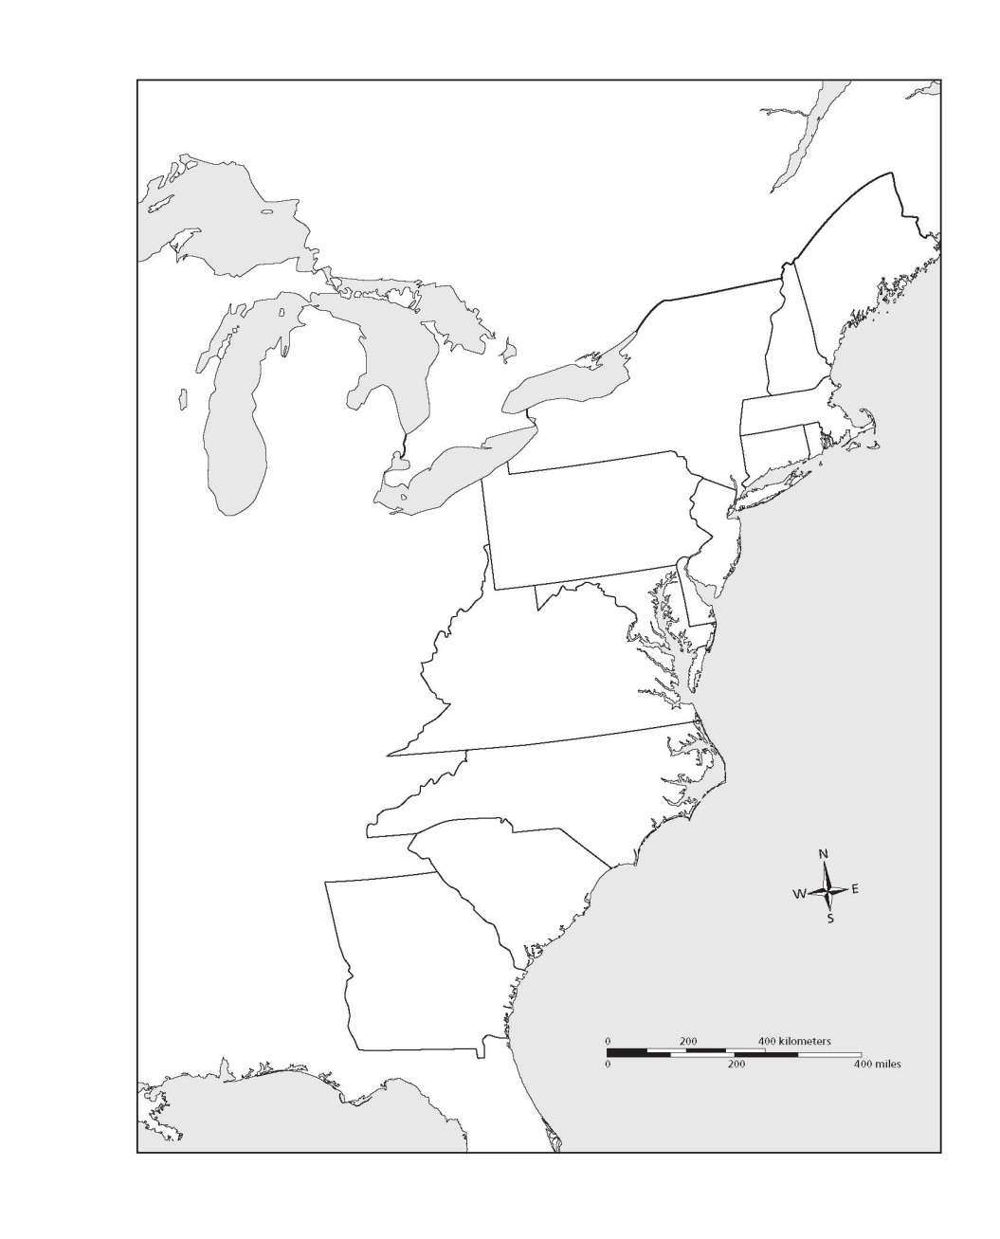
What reasons might explain why these three colonial regions were different in their purpose and activities? Explain your reasons. _________________
___________________________________________________________________________________________________________________________________________________________________________________________________________________________________________________________________________________________________________________________________________________________________________________________________
Identify the Key reasons for settlement and main economic activities in each of the three regions. Use the chart on pg 61 to help you.

*The New England Colonies
-Reason/s for settlement: __________
_______________________________
_______________________________
-Main Economic Activities: _________
_______________________________
_______________________________

*The Middle Colonies
-Reason/s for settlement: __________
_______________________________
_______________________________
-Main Economic Activities: _________
_______________________________
_______________________________

*The Southern Colonies
-Reason/s for settlement: __________
_______________________________
_______________________________
-Main Economic Activities: _________
_______________________________
_______________________________

