Monday, September 17, 2012

Tea Party Movement
Updated: Aug. 12, 2012
The Tea Party is an antigovernment, grass-roots political movement. It began in 2009 in protest of the bank bailout and economic stimulus package. Its supporters vowed to purge the Republican Party of officials they consider not sufficiently conservative and to block the Democratic agenda on the economy, the environment and health care. Tea Party supporters tend to unite around fiscal conservatism and a belief that the federal government has overstepped its constitutional powers.
The Tea Party became a pivotal player in the Republicans’ successful bid to take control of the House of Representatives in the 2010 midterm elections. In those elections, four in 10 voters expressed support for the movement in exit polls. Those figures, and victories at the polls, underscored the extent to which Republicans and Democrats alike may have underestimated the power of the party, a loosely affiliated coalition of libertarians and disaffected Republicans.
But two years later, the picture appeared quite different. The Tea Party initially appeared to display little impact on the course of the 2012 Republican presidential campaign.
Just months after Sarah Palin announced she would not run for president, her attempts to wield influence in the presidential primaries had largely fizzled. Representative Michele Bachmann of Minnesota, who calls herself a founding member of the Tea Party Caucus in Congress, bowed out of the presidential race after a disappointing finish in Iowa. Her Tea Party affiliation did little to help her campaign.
Herman Cain, who also claimed the mantle of the Tea Party, and Rick Perry, whose conservative views were in line with many members of the movement, both dropped out of the primary race.
Ryan Brings the Tea Party to the Ticket
Then, in August, Mitt Romney named Representative Paul D. Ryan of Wisconsin as his running mate. Mr. Ryan’s ascendancy to the No. 2 spot on the Republican ticket is a signal event for a movement that counts him as one of their own. If Mr. Romney wins in November, a Tea Party favorite will be a heartbeat from the Oval Office.
More than that, Mr. Ryan is now unquestionably the face of the Tea Party caucus in Washington, and his success is certain to embolden House lawmakers whose proudly unyielding approach to governance has contributed to legislative gridlock.
Once considered a fringe of the conservative coalition, Tea Party lawmakers are now indisputably at the core of the modern Republican Party.

Tea Party Looks To Recapture Election Magic In 2012
by Don Gonyea

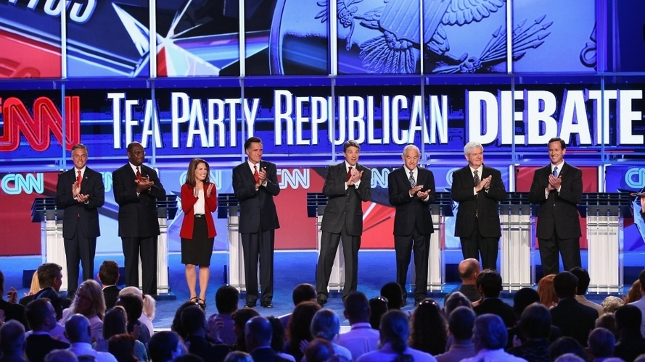
Win McNamee/Getty Images
Republican presidential candidates (from left) Jon Huntsman, Herman Cain, Rep. Michele Bachmann, Mitt Romney, Gov. Rick Perry, Rep. Ron Paul, Newt Gingrich and Rick Santorum prepare to debate during the event sponsored by CNN and the Tea Party Express at the Florida state fairgrounds on Sept. 12 in Tampa.
November 8, 2011
It was one year ago that the Tea Party movement helped Republicans take control of the U.S. House of Representatives. With the presidential election a year away, the movement finds itself searching for ways to have the same kind of impact this time around. The Tea Party celebrated on election night last year with candidates like Rand Paul, who captured a Senate seat in Kentucky. "Tonight there's a Tea Party tidal wave, and we're sending a message to them," Paul said in his victory speech. With the House victories, the congressional Tea Party caucus doubled in size to more than 60. Among them was Illinois Republican Joe Walsh, who said the group needs to keep the pressure on House Speaker John Boehner and other Republicans. "I've been hard on our leadership because I'm one of these Tea Party freshmen who want as many spending cuts as we can get," Walsh said in an NPR interview in April.
The Tea Party caucus took a hard line in debate over raising the debt ceiling this summer, pushing the government to the brink of default. The movement didn't get the result it wanted, but it did take credit for forcing a debate.

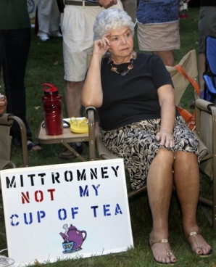
Jim Cole/AP
In this Sept. 4 file photo, Ann Kalifrath listens to Republican presidential candidate and former Massachusetts Gov. Mitt Romney speak at a Tea Party Express rally in Concord, N.H.
Through it all, the Tea Party kept an eye on 2012, with events like a summertime bus tour organized by Ryan Rhodes of the Iowa Tea Party. The Tea Party's goal is to have as big an impact on the presidential race as it did on congressional contests last year. An early favorite of the movement was Rep. Michele Bachmann of Minnesota. She kicked off her presidential campaign in Waterloo, Iowa, describing a GOP made up of fiscal and social conservatives. "It's made up of the Tea Party movement, and I am one of those," Bachmann said. But Bachmann has since dropped in the polls as other candidates have courted Tea Party votes. They are Herman Cain, who's battling allegations of sexual harassment, Ron Paul, Rick Perry, Newt Gingrich and Rick Santorum. The one thing most Tea Party activists seem to agree on is that they don't like Mitt Romney, whose big sin was signing a Massachusetts health care law. But the chill goes both ways. He was asked about the movement by NBC's Brian Williams at a debate in California. "Governor Romney, are you a member of the Tea Party?" Williams asked. "I don't think you carry cards in the Tea Party," Romney answered. "I believe in a lot of what the Tea Party believes in." Romney remains at or near the top of the polls even with little or no Tea Party backing. But he's not entirely without friends in the movement. "Governor Romney is not getting a fair shot from the Tea Party, from some in the Tea Party," said former U.S. Senate candidate Christine O'Donnell of Delaware.
While a favorite of the Tea Party, O'Donnell lost the 2010 race for the seat once held by Vice President Joe Biden. It was a race Republicans expected to win, had O'Donnell not knocked off moderate Republican Rep. Mike Castle in the primary. O'Donnell's primary win was a victory of ideology over electability. Now she defends Romney, citing electability. "We need to consider who is going to be able to beat Barack Obama, and right now we've got a field of candidates, and some of them are going to get crushed by the Obama machine and some of them have the infrastructure to beat Barack Obama," O'Donnell said.
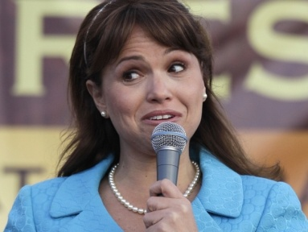
Rob Carr/AP
Delaware Republican Senate candidate Christine O'Donnell delivers remarks at the Tea Party Express rally in 2010. Some say Republicans threw away votes by nominating ultra-conservative O'Donnell.
The Tea Party does have a much higher profile this election. It even flirted with the establishment by teaming up with CNN for a televised debate. But that event also brought about memorable moments, like when moderator Wolf Blitzer asked candidate Ron Paul what happens if someone chooses not to purchase health insurance, has an accident and winds up in the hospital in a coma. Should society just let him die, Blitzer asked? Paul answered "no," but an audience member shouted "yes." It prompted a new round of criticism of the Tea Party as heartless and ready to dismantle the social safety net.
Over the past year, public support for the movement has fallen off. In a September CNN poll, 53 percent of Americans surveyed had an unfavorable opinion of the Tea Party. "We have taken some hits," says Matt Kibbe of FreedomWorks, one of several national organizations that has given financial and other support to the movement. "Our negatives are up some, but that's the price of leadership." Kibbe says the Tea Party of today is very different from the one that began in 2009. "It's a natural evolution," Kibbe explains. "We started as a protest movement. We morphed into a get-out-the-vote machine, but now we're literally thinking locally and acting nationally, and that to me is an exciting and maturing of the Tea Party movement." Kibbe says it's too soon to say if there will be a presidential nominee the movement can rally around. If not, he says, the focus will be on House and Senate races. He says they know they can have an impact there — just as they did one year ago.

