StudentStockTrader
Code: 19308-63667
Student Stock Trader is a stock market simulator that allows students to build and manage their own stock market portfolios while safely competing against other class members for the highest performing portfolio!

How do I Get Started? :
Think about the companies you might invest in, start with what you already
know. First, create a list of the products or websites you use. Look for things you have at home like cleaning
products, dish soap, bath soap, laundry detergent, food items in the refrigerator or cupboard.
In addition to the product name, look into the company that makes the product, from here you can explore where the product was bought, who makes the product, and possibly other products the company produces.

Understanding Public Companies:
As you create a list of companies from the products you use in your home or class, you’ll will come across companies that are not listed on the stock market.
This means that these companies are either
- Privately owned
- Is a subsidiary of another company
- Is a brand name
- Is listed on another stock exchange
How to Join the Game:
Student Stock Trader does not require students to provide any personal information. A student may choose a display name that helps other students in the game recognize them.
Once a game has been created by the teacher, navigate to the game settings section and look for the join url. Share this URL with the class or students that you wish to join your game.
Each student will be required to enter a 'Display Name' that will be shown to other students. No email address or other personal information will be stored.
If students use a Google or Facebook account to access Student Stock Trader, then we only store enough information to make the game playable (display name and email address).
The join will be in the form of a number such as XXXX-0. The -0 is a generic join code for a game, it does not have any personal information in it. Once a user joins the game they will be assigned a specific code in the form XXXX-XXX. This code must be used to rejoin the game at a later date. If a user were to use the -0 code they will join as a new user. Teachers can view the assigned student codes on the leaderboard screen should a student forget their unique code.
A student can also use their display name and the generic join code to rejoin (if the setting option allows it).

How do I Read Stock Data? :
The following information can be used when reading the stock information of a company:
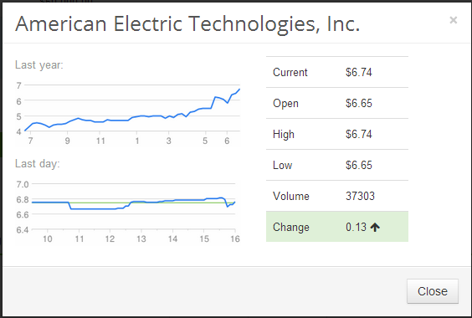
- Current – The current price of the stock, this will be the price the transaction occurs at.
- Open – This is the price that the stock last opened at. This gives you an idea of how much the stock has moved since the last trading day opened.
- High – This is the highest value the stock has reached in the last trading day.
- Low – This is the lowest value the stock has reached in the last trading day.
- Volume – The amount of shares that have been traded in the last trading day. This is helpful to understand if there has been lots of activity on this stock which might indicate that investors think it’s good or bad.
- Change – The percentage change from it’s opening value to the current value.
- Charts: The top chart is the last year, the bottom chart is the last trading day. Helpful to view trends.

