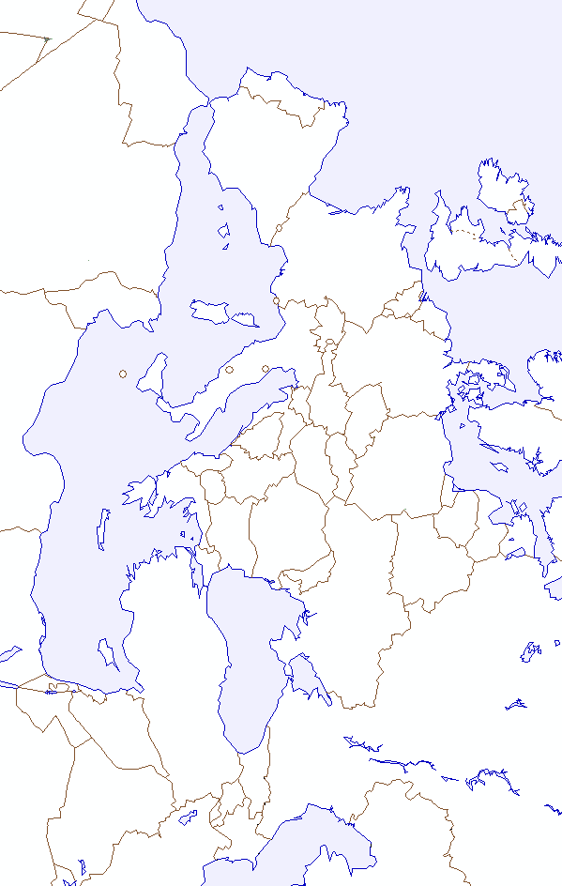

“Retaking Europe”
Map Activity

Instructions: Follow the step-by-step list of activities below. It is important to do them in the order provided so that you may recognize and understand the sequence of events.

- Lightly shade ALL area occupied by the Axis Powers (Germany and Italy) in 1942.

- The North Africa Campaign:
  - Using labeled arrows (indicating Allied force and commanding general), indicate from where the Americans and the British invaded Nazi forces in N. Africa.
  - Identify, label, and date the location of the Battle of El Alamein.

- The Invasion of Italy:
  - Using labeled arrows, indicate the route taken by US and British forces in their invasion of Italy.
  - Identify, label and date the location of the Battle of Al Anzio.

- War in the Soviet Union:
  - Identify, label and date the location of the Battle of Stalingrad.
  - Using dated arrows, indicate the Soviet advance westward.
  - Mark which countries came under Soviet control as they pushed the Nazis west.
  - Identify, label and date the Soviet capture of Berlin.

- The Invasion of Western Europe:
  - Identify and date the D-Day invasion of Nazi-occupied France at Normandy.
  - Using labeled arrows, indicate the route taken by the allied forces to recapture France.
  - Identify and date the location of the Battle of the Bulge.

- Germany Surrenders:
  - Identify, label, and date the location of the Yalta Conference. List which leaders met there.

** On a separate sheet of paper, explain why each of the following was important in the fight against the Axis Powers. Back up your explanation with SPECIFIC content detail.

- The Battle of Al Anzio
- The Battle of Stalingrad
- The D-Day Invasion
- The Battle of the Bulge

