Europe 1914
(pre WWI)

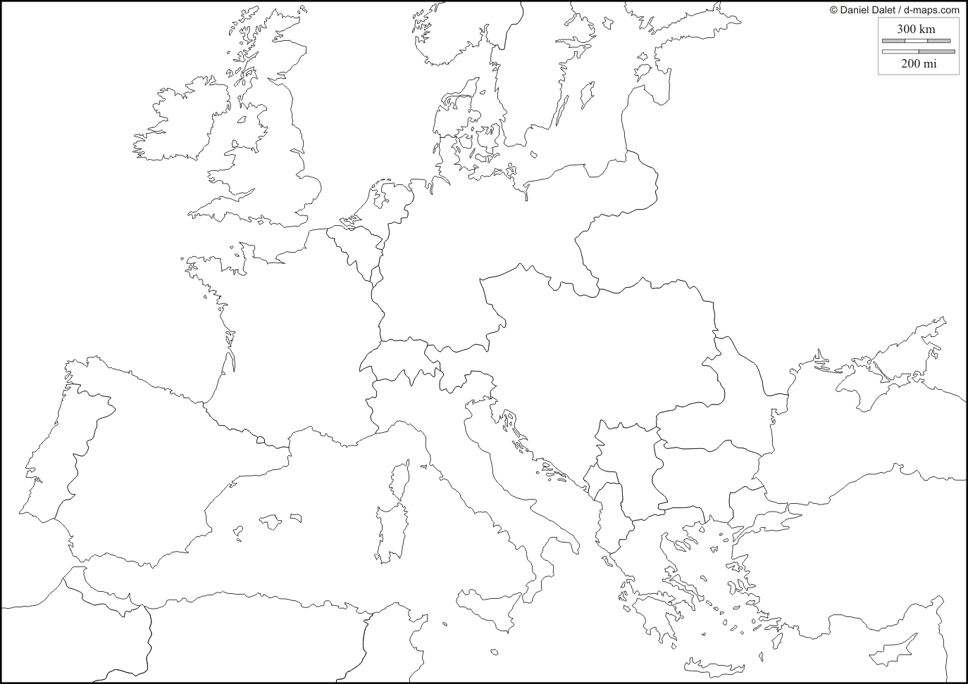
Locate the Following:
- Axis Powers:
  - _____________________________
  - _____________________________
  - _____________________________
  - _____________________________
- Allied Powers:
  - _____________________________
  - _____________________________
  - _____________________________
  - _____________________________

- Serbia
- London
- Paris
- Moscow

