Document Analysis Activity #2 Name: ___________________________________________

“A picture is worth a thousand words”… even more-so in the case of politically motivated imagery (AKA Political Cartoons). They stand as vivid evidence of the views and attitudes of the period in which they were created. Lets look at the example below and see what this image can tell us.
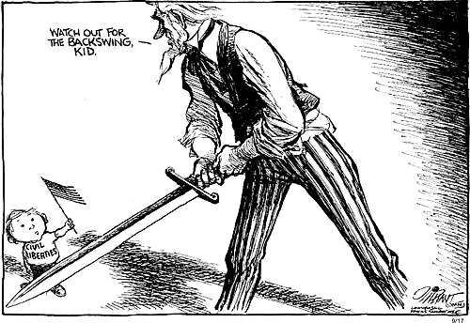
- Who is the “Speaker”? (voice)
_________________________________________________________________________________
_________________________________________________________________________________
- What is the Occasion? (time and place of the piece).
_________________________________________________________________________________
_________________________________________________________________________________

- Who is the intended Audience?
_________________________________________________________________________________
_________________________________________________________________________________

- What is the Purpose? (reason for it)
_________________________________________________________________________________
_________________________________________________________________________________

- What is the Subject?
_________________________________________________________________________________
_________________________________________________________________________________

- What is the Tone? (attitude/mood)
_________________________________________________________________________________
_________________________________________________________________________________
_____________________________________

