Document Analysis Activity #1 Name: ___________________________________________

“A picture is worth a thousand words”… even more-so in the case of politically motivated imagery (AKA Political Cartoons). They stand as vivid evidence of the views and attitudes of the period in which they were created. Lets look at the example below and see what this image can tell us.

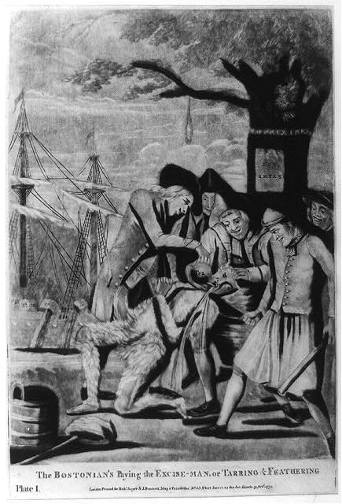
- Who is the “Speaker”? (voice)
_____________________________________
_____________________________________

- What is the Occasion? (time and place of the piece).
_____________________________________
_____________________________________
_____________________________________

- Who is the intended Audience?
_____________________________________
_____________________________________

- What is the Purpose? (reason for it)
_____________________________________
_____________________________________
_____________________________________

- What is the Subject?
_____________________________________
_____________________________________
_____________________________________

- What is the Tone? (attitude/mood)
_____________________________________
_____________________________________
_____________________________________

