**Thirteen Colonies-Three Regions Name: ___________________________**

**Map Activity Period: _________**

**Add the following elements to the map:**

* Label each of the 13 colonies
* Shade/color the 3 colonial regions and label each. Use the map on pg 35 of your text to help you.
* Identify, shade/color, and label French and Spanish territories found on this map.

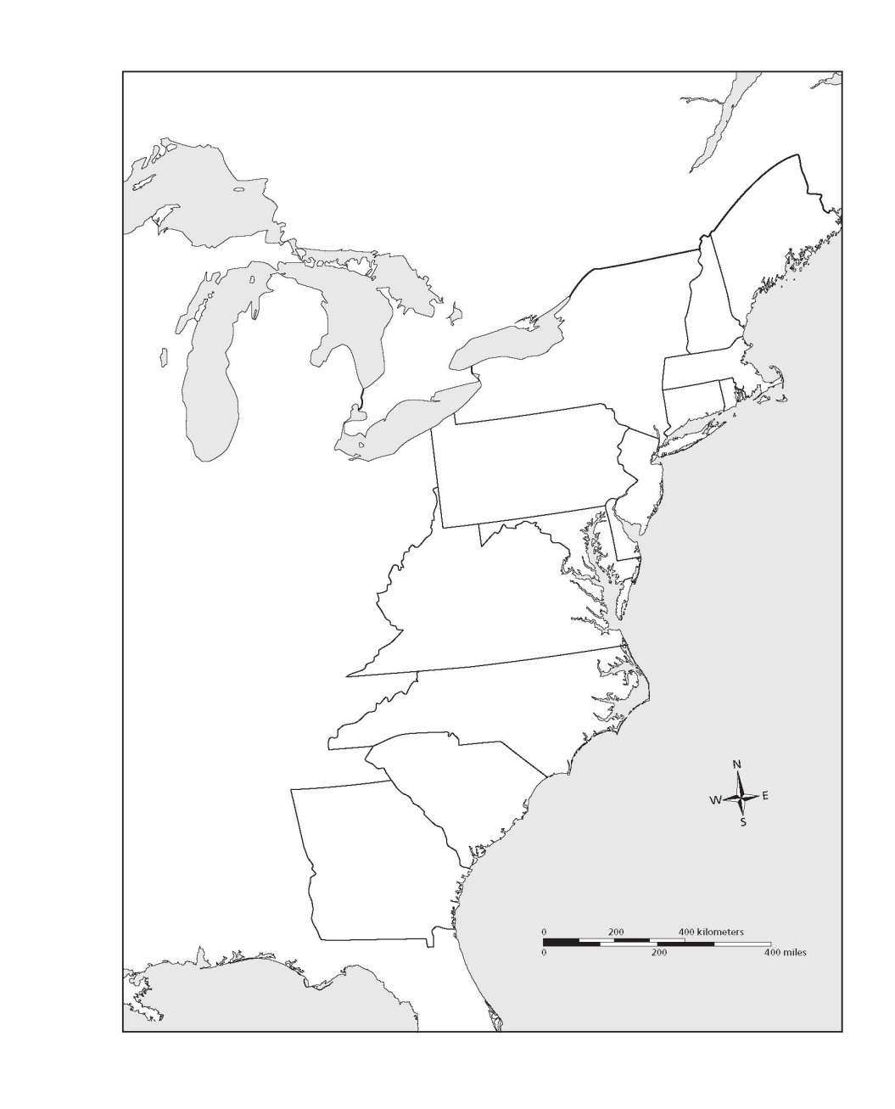

What reasons might explain why these three colonial regions were different in their purpose and activities? Explain your reasons. _________________

___________________________________________________________________________________________________________________________________________________________________________________________________________________________________________________________________________________________________________________________________________________________________________________________________

Identify the Key reasons for settlement and main economic activities in each of the three regions. Use the chart on pg 61 to help you.

**\*The New England Colonies**

-Reason/s for settlement: __________

_______________________________

_______________________________

-Main Economic Activities: _________

_______________________________

_______________________________

**\*The Middle Colonies**

-Reason/s for settlement: __________

_______________________________

_______________________________

-Main Economic Activities: _________

_______________________________

_______________________________

**\*The Southern Colonies**

-Reason/s for settlement: __________

_______________________________

_______________________________

-Main Economic Activities: _________

_______________________________

_______________________________